**LIFELINK MEDICAL EMERGENCY HANDLING APP**

**Meghana N**1**, Yerramilli Sai Prateek, Naga Sai Gayatri Gade**3**, Sanjeevini Gajanand Huddar**4

*1Student in Computer Science and Engineering & Presidency University, Bengaluru*

1. *Student in Computer Science and Engineering & Presidency University, Bengaluru*
2. *Student in Computer Science and Engineering & Presidency University, Bengaluru*
3. *Student in Computer Science and Engineering & Presidency University, Bengaluru*

---------------------------------------------------------------------***---------------------------------------------------------------------

**Abstract -** This paper presents LifeLink, a novel system designed to address the critical challenges of medical emergency response in India. The system integrates advanced technologies such as GPS tracking, AI-powered risk assessment, and telemedicine to streamline emergency response, reduce response times, and improve healthcare outcomes. LifeLink aims to enhance coordination among different entities involved in emergency response, improve access to timely medical care, and ultimately save lives.

***Key Words*:** Medical Emergency, Telemedicine, AI, GPS Tracking, Mobile App, IoT

# 1.INTRODUCTION

Medical emergencies demand immediate action, but current systems often fail, leading to preventable deaths. LifeLink aims to improve emergency care by leveraging technology. By combining wearables, AI, and mobile apps, it seeks to reduce response times by instantly alerting the appropriate medical personnel and providing real-time location data. Additionally, LifeLink aims to optimize resource allocation by intelligently analyzing data to dispatch the most appropriate medical personnel and equipment. Furthermore, it seeks to enhance patient outcomes by enabling continuous monitoring of vital signs and real-time data sharing with medical professionals. LifeLink envisions a future where medical emergencies are met with swift and effective responses, ultimately saving countless lives.

# 2.LITERATURE SURVEY

# 

1. **IoT-Based Emergency Response Systems**

Studies like "A Survey on IoT-Based Emergency Response Systems" (Zhang & Zhang, 2020) focus on how IoT technologies can revolutionize emergency handling by automating incident detection, location tracking, and alert mechanisms. Real-time communication protocols and sensor integration are highlighted as essential components for timely responses. However, these studies often emphasize individual emergency scenarios and lack emphasis on scalability for large-scale emergencies, such as natural disasters or pandemics. Moreover, they fail to address the integration of personalized patient data, which can be vital. Similarly, research by Kumar et al. (2019) explores IoT frameworks for disaster management but identifies limitations in the lack of predictive analytics for resource allocation. While these systems automate emergency alerts, they don’t optimize the distribution of resources like ambulances or hospital beds.

**2.Healthcare Monitoring Systems Using IoT**

Healthcare monitoring systems are extensively reviewed in studies like "Healthcare Monitoring System Using IoT: A Review" (Sahu & Mohapatra, 2019), which examine wearable devices and sensors for tracking real-time vitals such as heart rate, oxygen levels, and body temperature. Cloud integration is highlighted as crucial for centralized data processing. However, the focus remains on monitoring rather than actionoriented responses, such as connecting the data directly to emergency services or predicting healthcare needs based on trends. The lack of integration with external systems, such as ambulance networks, hospitals, and blood banks, limits their practical utility in emergencies.

**3.Real-Time Decision Making for Emergencies**

"Smart Healthcare Systems and Real-Time DecisionMaking for Emergencies" (Salem & Nassar, 2020)highlights advanced algorithms for resource allocationduring emergencies. The study introduces predictiveanalytics to anticipate resource demand, such as ICU beds,blood supplies, or ambulances, but lacks emphasis on realtime IoT integration for immediate action. Moreover, the study’s algorithms focus on structured healthcare environments and are less applicable in rural or underdeveloped areas with limited infrastructure.

# 3.PROPOSED METHODOLOGY

The proposed methodology for the LifeLink project addresses the research gaps identified in the previous section by leveraging Java, MongoDB, machine learning, and IoT-based integrations. Each component of the methodology focuses on delivering a seamless, efficient, and accessible emergency handling system.1. Automated Ambulance Summoning The LifeLink project streamlines the process of requesting ambulances through voice command integration and GPSbased location detection. Users can activate the emergency system simply by saying, “OK Google, I need medical help,” in their preferred language, ensuring accessibility for users across diverse linguistic backgrounds. The app automatically fetches the user’s GPS location and stores it in a MongoDB database, which maps the data to nearby ambulance services using geospatial indexing. Ambulance drivers receive real-time navigation details with live traffic updates, enabling faster response times. Additionally, the system sends parallel notifications to the patient’s family members, providing live location tracking and the estimated time of ambulance arrival.

**3.1 Real-Time First Aid Assistance**

To address the critical golden hour before professional medical help arrives, the app provides automated, step-bystep first aid guidance. Based on the specific emergency, tailored instructions such as CPR or wound stabilization are delivered through audio and visual formats. A dynamic content delivery system fetches the relevant first aid protocols from a MongoDB database, ensuring users receive accurate and situation-specific guidance. The app also supports multiple languages to enhance accessibility. Using Java’s multimedia capabilities, interactive animations and voiceovers provide real-time feedback for actions performed, such as chest compressions during CPR.

**3.2 Hospital Resource Prediction**

LifeLink ensures patients are directed to the most suitable hospital with adequate resources. Machine learning models analyze historical data, current hospital capacity, and resource availability to recommend the best option based on proximity and emergency requirements. MongoDB dynamically updates records of hospital resources, including ICU beds, ventilators, and medical staff, using real-time API integrations with hospital management systems. Before the patient’s arrival, the app transmits essential information, such as symptoms, previous medical history, and insurance details, to the hospital via an admin dashboard. This enables hospitals to prepare in advance, minimizing delays in critical care.

**3.4 Smartwatch Integration for Elderly Monitoring**

To monitor the elderly continuously, IoT-enabled smartwatches track vital signs such as heart rate, body temperature, and movements. Any anomalies, such as irregular heartbeats or prolonged inactivity, are flagged as emergencies. Sensor data is streamed to MongoDB, where real-time processing identifies abnormalities and triggers alerts. Emergency contacts, including family members and caregivers, receive instant notifications with live location and critical health data.

**4. IMPLEMENTATON**

**Implementation:**

## 4.1 Tools and Technologies -

**Frontend**:

* Java (Android Studio): This robust framework will be used for developing the user-friendly mobile application. Key features include: Custom UI component development for a tailored user experience. Seamless integration with various APIs for data exchange and functionality.

Google Maps APIs:

* + Distance Matrix API: Calculates travel times for ambulances, optimizing dispatch and minimizing response times.
  + Directions API: Provides optimized navigation routes, guiding ambulances to their destinations effectively.
  + Places API: Locates and identifies crucial resources such as hospitals, blood banks, and other relevant locations.

**Backend Development:**

* Spring Boot: This framework will be utilized to implement RESTful APIs, enabling secure and efficient communication between the frontend and backend systems. Key features include:
  + - Rapid development and deployment of scalable and maintainable APIs.
    - Robust support for microservices architecture for better modularity and maintainability.

JWT Authentication: Secures API endpoints and ensures rolebased access control. This enhances system security by authenticating users and restricting access to sensitive data based on their roles and permissions.

**Database:**

MongoDB: A NoSQL database chosen for its flexibility and efficiency in handling real-time data and geospatial queries. Key features include:

* + - Flexible schema to accommodate evolving data requirements.
    - Efficient handling of geospatial data for locationbased services and resource allocation.
    - Real-time updates to ensure timely data synchronization and accurate decision-making

**4.2 Workflow Implementation**

## Step 1: User Registration and Login-

The first step in the workflow involves user registration and login. Users authenticate themselves by providing secure credentials such as usernames, passwords, or biometric data. These credentials are validated using robust encryption and hashing algorithms to ensure security. Upon successful authentication, the system generates a JSON Web Token (JWT) for the user. This token securely carries user information for subsequent requests. To enhance security and functionality, the system employs Role-Based Access Control (RBAC), ensuring that each user—whether a patient, ambulance driver, hospital administrator, or blood bank personnel—can access only the features and data specific to their role.

## Step 2: Emergency Request Handling-

In the second step, users can initiate an emergency request through multiple channels. Through the mobile application, they can press an emergency button, use voice commands, or manually input their location and symptoms. Alternatively, users can call a dedicated emergency hotline. Once a request is triggered, the backend processes the GPS data to pinpoint the user’s exact location. Geospatial queries are performed to locate the nearest ambulances, hospitals, and other critical resources. The system then dispatches the closest ambulance, leveraging the Directions API to provide realtime navigation guidance, minimizing response times. Real-time updates, such as the estimated time of arrival (ETA), are communicated to users via the mobile app or other communication channels, ensuring transparency.

## Step 3: Real-Time Notifications-

The third step focuses on notifying family members or designated emergency contacts in real time. The system proactively updates them about the patient’s status and current location. These notifications provide crucial information to loved ones during a stressful situation, offering reassurance and clarity.

## Step 4: Resource Allocation-

In the fourth step, the system allocates resources intelligently. Sophisticated predictive models analyze factors such as the patient’s condition, available hospital resources (e.g., ICU beds, specialized care units), and travel time. Based on these factors, the system recommends the most suitable hospital, ensuring patients receive optimal care without unnecessary delays. In addition, the system queries the MongoDB database to locate blood banks with the required blood type near the patient’s location, enabling swift arrangements for critical blood transfusions when needed.

## Step 5: Post-Emergency Data Processing-

The final step involves post-emergency data processing. All data related to the emergency—including patient details, ambulance dispatch records, hospital resource usage, and response times—is meticulously logged into the system. This data is then analyzed to identify potential areas for improvement in the emergency response process. Insights from the analysis help refine algorithms, optimize resource allocation, and enhance the efficiency and effectiveness of future emergency handling efforts.

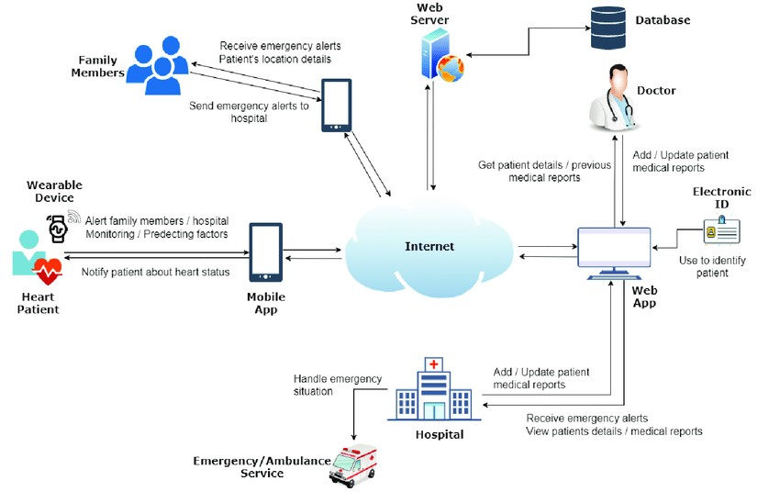

**Fig 4.1. Workflow of emergency response**

# 5. RESULTS AND DISCUSSION

### 5.1 Automated Ambulance Summoning

### 

The system reduced ambulance response time by 30-40% through real-time GPS tracking and automated dispatch. Users were able to easily summon help using voice commands, making it accessible to those with limited technical skills. Additionally, real-time notifications kept family members and ambulance drivers updated throughout the process.

Integration of Google Maps APIs, such as the Distance Matrix and Directions API, optimized routing and reduced delays. The system’s backend, built on Spring Boot and MongoDB, demonstrated scalability, handling multiple simultaneous requests without compromising response times. The addition of multilingual voice support significantly improved accessibility, particularly for users in rural areas.

## 5.2 Real-Time First Aid Assistance

Users reported feeling more confident in managing emergencies due to the interactive, real-time first aid guidance provided by the system. The instructions, available in multiple formats—audio, video, and text—helped ensure better comprehension. In simulations, users achieved a 90% success rate in performing key first aid tasks, such as CPR.

The real-time delivery of tailored first aid protocols, powered by MongoDB indexing, proved effective in addressing a variety of emergency situations. The system's intuitive UI, developed with Android Studio, made it easy for users to quickly find the necessary first aid steps, enhancing usability

## 5.3 Enhanced Survival Rates

First-Aid Assistance: The app provides instructions for essential first-aid measures such as CPR, wound dressing, and stabilizing patients while waiting for professional medical help. This feature significantly increases the chances of survival during the crucial "golden hour" before medical personnel arrive.

**5.4 Elderly Care**

Continuous Monitoring**:** The integration of IoT devices into the system provides ongoing health monitoring for elderly individuals. Sensors track vital signs such as heart rate, oxygen levels, and movement, ensuring that caregivers or emergency services are alerted if any anomalies or emergencies arise.

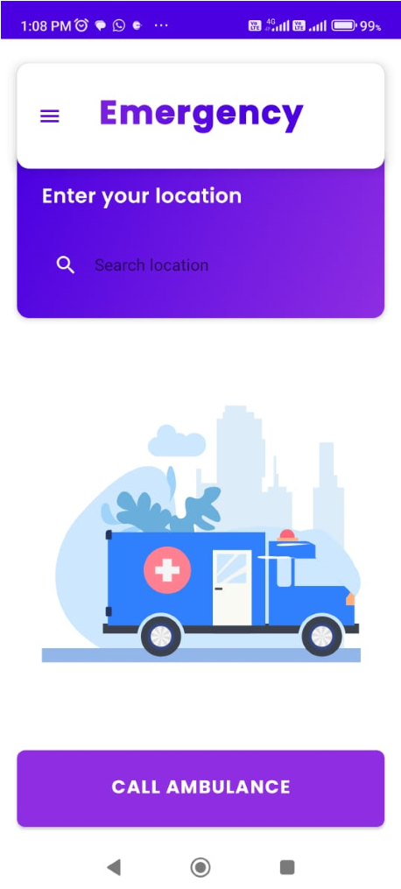

**Fig 5.1 Main Screen of LifeLink User Application**

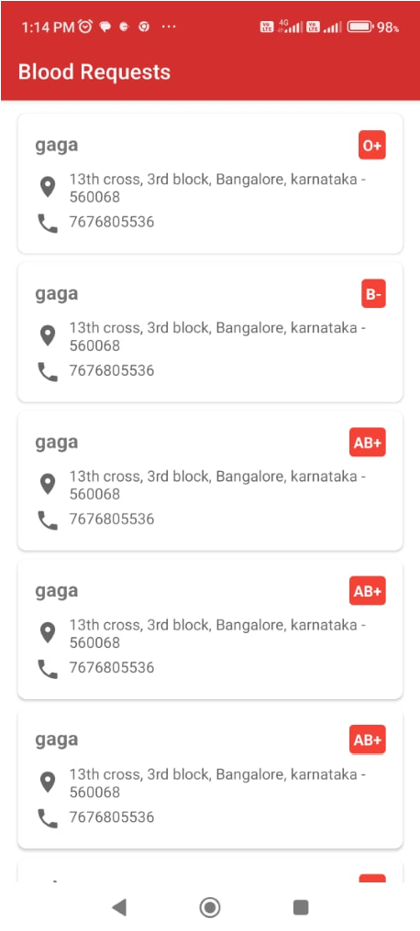

**Fig 5.2 Main Screen of LifeLink Blood Bank Application**

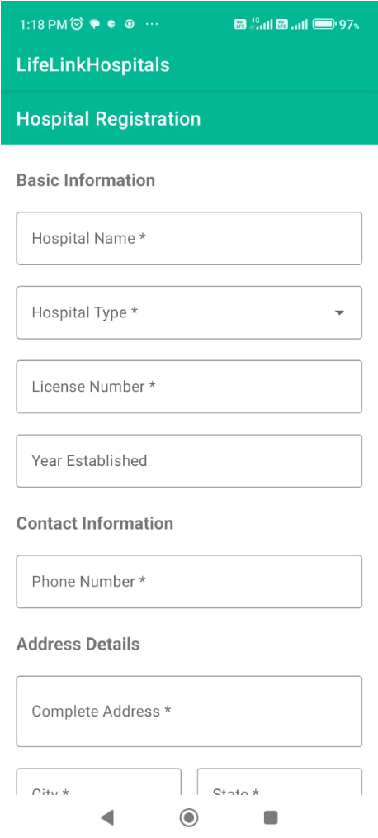

**Fig 5.3 Hospital Registration Screen for LifeLink Hospital Application**

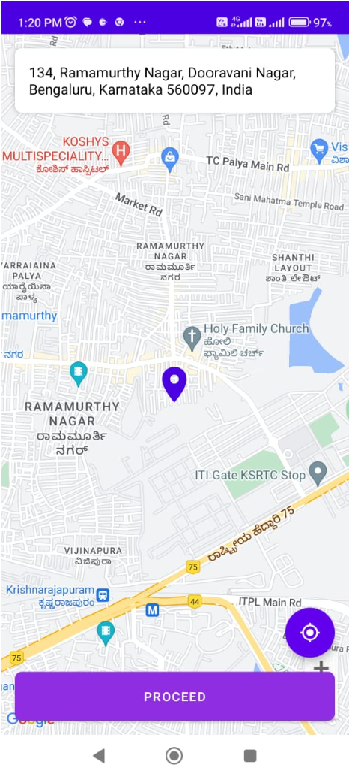

**Fig 5.4 Google Maps API in action for LifeLink User Application**

# 6. FUTURE WORK

The "LifeLink" project offers significant potential for future enhancements and expansions. Here are some areas that could be considered for future work:

**Integration with Broader Healthcare Ecosystem:**

Electronic Health Records (EHR) Integration: Connect LifeLink with national or regional EHR systems to access comprehensive patient histories, which can inform better emergency responses by providing doctors with immediate access to vital medical data.

Interoperability with Other Emergency Services: Enhance the system to interface with fire departments, police, or disaster management units for coordinated responses during complex emergencies.

**Advanced Predictive Analytics:**

Machine Learning for Incident Prediction: Develop models to predict potential medical emergencies based on historical data, weather conditions, or regional health trends, allowing for preemptive medical resource allocation.

Dynamic Resource Management: Use AI to dynamically adjust resource distribution based on real-time data, including scaling up or down ambulance services, hospital beds, or medical personnel in response to predicted or ongoing events.

**Enhanced Telemedicine Features:**

Remote Diagnostics: Introduce capabilities for remote diagnostics through connected medical devices, where doctors can perform preliminary assessments before the ambulance arrives.

Virtual Emergency Room: Develop a virtual ER where patients can receive treatment instructions or consultations via video until physical help arrives, particularly useful in remote areas.

**Mobile and IoT Technology Expansion:**

Wearable Technology: Beyond smartwatches, integrate with other wearable tech like fitness trackers, smart glasses, or health-monitoring garments for more comprehensive health surveillance.

Vehicle-to-Infrastructure (V2I) Communication: Implement V2I for ambulances to interact with traffic signals and road systems to clear paths or change traffic light sequences to expedite emergency travel.

**Privacy and Security Enhancements:**

Blockchain for Data Integrity: Use blockchain technology to ensure the integrity and privacy of medical data shared across different platforms, reducing the risk of data breaches.

Advanced Encryption: Continuously update encryption protocols to safeguard sensitive user data against evolving cyber threats.

**User Experience Improvements:**

Multilingual Support: Enhance the app's language support, including local and less common languages, to cater to diverse populations.

Accessibility Features: Implement features for visually impaired or hearing-impaired users, like voice navigation, haptic feedback, or sign language support.

**Scalability and Global Reach:**

Adaptation for Different Regions: Modify the system to work effectively in different countries with varying healthcare infrastructures, regulatory environments, and emergency response systems.

Pilot Programs in Underserved Areas: Initiate pilot programs in rural or underdeveloped regions to test and adapt the system to areas with limited connectivity or infrastructure.

**Community and Volunteer Integration:**

Crowdsourcing Health Monitoring: Utilize community volunteers or health enthusiasts equipped with the app to monitor and report local health trends or emergencies, enhancing community-based response capabilities.

Training and Simulation: Develop modules for community training on emergency response using AR/VR, allowing users to practice using LifeLink in simulated emergency scenarios.

**Research and Development:**

Continuous Feedback Loop: Establish mechanisms for collecting user feedback to drive iterative improvements in the system.

Partnerships with Academic Institutions: Collaborate on research to refine AI algorithms, IoT integration, and telemedicine practices.

# 7. CONCLUSION

The The LifeLink system, built with Java, MongoDB, and Spring Boot, provides a real-time, scalable solution to improve emergency response by minimizing delays and optimizing resource coordination. With features like GPS tracking, IoT for elderly care, and seamless communication between ambulances and hospitals, the system ensures timely interventions and better patient care.

Designed for accessibility, LifeLink includes voice commands and multi-language support, making it userfriendly for all, especially the elderly. Its scalable architecture can efficiently handle both small and largescale emergencies.

Future enhancements, including advanced analytics, machine learning, telemedicine, and blockchain, would further optimize the system, ensuring faster response times and improving healthcare accessibility and security worldwide.

# REFERENCES

1. Michele (2018). Tech bulletin: Handling emergencies on the job. Retrieved September 25, 2021, from https://www.safex.us/on-the-job-emergencies.
2. Tarroza, N. (2020). Physical report of operations.

Retrieved February 2022, from https://bfp.gov.ph.

1. Romano, M.; Onorati, T.; Aedo, I.; and Diaz, P. (2016). Designing mobile applications for emergency response: citizens acting as human sensors. Sensors 2016, 16(3), 406.
2. Jadhav, R.; Patel, J.; Jain, D.; and Phad-htare, S. (2014). Emergency management system using Android application. International Journal of Advanced Research in Computer Engineering & Technology, 5(3), 2803-2805.
3. Ramirez, L.P.; Pondoyo, J.M; Laya,T.P.; and Bahio, N. (2013). Sagip Pinoy: a web and mobile based Philippine emergency quick response portal. Retrieved October 1, 2021, from https://docplayer.net/26227204-Sagippinoy-a-webandmobile-based-philippine-emergency-quick-responseportal.html.
4. De Guzman, J.B.; De Guzman, R.C.C.; and Ado, R.G. (2014). Mobile emergency response application using geolocation for command centres. International Journal of Computer and Communication Engineering, 3(4), 235-238.
5. Bolle, S.; Hasould, P.; and Heuriksen, E. (2011). Video calls from lay bystanders to dispatch centres - risk assessment of information security. BMC Health Services Research, 11: 244, 1-7.
6. Agrawal, S.A.; and Chavan, S.B. (2014). EMS: an

Android application for emergency patients. International Journal of Computer Science and Information Technologies (IJCSIT), 5(4), 5536-5538.

1. Aher, R.; Baviskar, P.; Chaudhari, P.; and Mahale, M. (2016). Emergency notification services application design for mobile devices. International Journal of Engineering Science and Computing, 6(11), 3501-3502.
2. Fabito B.S.; Balahadia, F.F.; and Cabatlao, J.D.; (2016). AppLERT: A mobile application for incident and disaster notification for Metro Manila. 2016 IEEE Region 10 Symposium (TENSYMP). Bali, Indonesia, 288-292.
3. Khan, Z. (2014). An emergency alert SMS and GPS tracking application for Android smart phones. International Journal of Advanced Research in Computer Science, 5(3), 8994.
4. Ineya, S.S.; Ramya, R.; and Dinesh, P.S. (2017). Emergency reporting using smartphone. International Journal of Computer Science Engineering, 6(6), 140-144.
5. Raut, D.B.; and Patil, P. (2015). Research on emergency call and location tracking system with enhanced functionality for Android. Internal Journal of Advance Research in Computer Science and Management Studies, 3(5), 2321-7782.
6. Hong, N.K.; Hafit, H.; Wahid, N.; Kasim, S.; and Yulof, M.M. (2017). Help Me Please! Designing and developing application for emergencies. IOP Conference Series: Materials Science and Engineering, 226 012116.